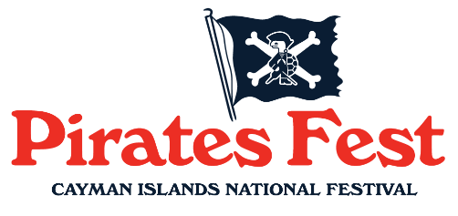
PIRATES FESTIVAL, CAYMAN ISLANDS AQUATIC
SPORTS ASSOCIATION
& KPMG
Present

The 45th Annual Pirates Fest KPMG
5k, 3k and 1k sea swim
Saturday 15 November 2025

WHERE | Governor’s Beach
TIME | Race starts at 7:30 am  Registration at Governor’s Beach from 6:15 am to 6:45 am
CUT-OFF TIME | 2¼ hours from Race Start
COURSE | 1k rectangular loops starting & finishing at Governor’s Beach
ENTRY FEES | CIASA Members: CI$30  Non-Members: CI$35
RACE CAPS | Race caps will be provided upon registration & swimmers are required to wear them to ensure safety during the race
AWARDS | Trophies or medals for first, second and third places in all age groups.  T-shirts and refreshments

If weather conditions threaten the safety of the swimmers or organisers, the race may be cancelled at the discretion of the Race Director.

___________________________________________ _________________ _____ ________
NAME DATE OF BIRTH AGE ANY MEDICAL CONDITIONS? YES NO
(on race day) (if YES, list details above)

___________________________________________ ________________________________ CIASA Member? YES NO
PHONE NUMBER EMAIL

PLEASE CIRCLE YOUR DIVISION CODE
 | 5k |  | 3k |  | 1k
AGE GROUP  (as of race day) | MALE | FEMALE | MALE | FEMALE | MALE | FEMALE | RACE NUMBER
10 – 19 years | A | E | J | N | S | W
20 - 39 years | B | F | K | P | T | X
40 - 59 years | C | G | L | Q | U | Y
60 years & over | D | H | M | R | V | Z

DECLARATION AND DISCLAIMER OF LIABILITY
YOUR ATTENTION IS BROUGHT TO THE FOLLOWING WHICH YOU SHOULD READ CAREFULLY
By completing this form, I declare, verify and understand that:
- I am physically fit for the event, I am a competent swimmer and I have no medical reasons why I should not participate in this event.
- I agree to abide by all of the event regulations stated.
- I agree to participate entirely at my own risk, the extent of which I fully appreciate and I waive all possible rights that I may have, or my heirs or dependents may have, as a result of any injury, loss to property or death which may occur as a result of my participation in this event, in consideration of me participating in this event.
- I accept that no liability whatsoever will attach to CIASA, the organisers, sponsors, volunteers or anyone else involved with Cayman Swimming and that they are in no way responsible for the safety of any swimmer, in consideration of me participating in this event.
- I consent to the use of photographic images of myself in official event photos.

Signed _________________________________________ or __________________________________________

SWIMMER GUARDIAN (if swimmer is under 18 years old)


