The Cayman Islands Aquatic Sports Association (“CIASA”) invites member clubs and eligible swimmers to participate in the Cayman Islands National Swimming Championships 2025.

|  |  |
| --- | --- |
| **SANCTIONED BY:** | Cayman Aquatic (“**CIASA”**) |
| **POOL DATES AND START TIMES:** | 6 March – 9 March, 2025   * Thursday and Friday: Prelims @ 8:00AM and Finals @ 6:00PM * Saturday and Sunday: Prelims @ 8:30AM and Finals @ 5:30PM |
| **POOL VENUE:** | Camana Bay Sports Complex  **\*\*\*CIASA EVENTS AND THE CAMANA BAY POOL ARE NUT-FREE\*\*\*** |
| **COURSE:** | Outdoor 25 metre pool with 8 lanes; only 6 lanes will be used for competition. During competition one lane may be used for warm-up/cool-down with one unused lane between the racing course and the warm-up/cool-down lane. Prelims may be run in fewer than 6 lanes should the Meet Referee decide we do not have the number of officials needed to properly officiate the session. The decision to use fewer than 6 lanes will be taken thirty minutes (30min) before the start of each relevant session; this is the time needed to reorganise the programme. See Rule 18. |
| **WARM-UP:** | * Thursday and Friday: @ 6:30 AM and 4:30PM * Saturday and Sunday: @ 7:00AM and 4:00PM   All lanes will be open for coach supervised warm-up during designated warm-up times. The pool will close 15 minutes prior to the start of each session. During prelims and finals swimmers may warm-up or cool-down in the one outside lane.  Feet first entry will be required by all swimmers during warm-up except in lanes officially designated for warm up dives and sprints.  During competition, entry into the warm-up lane may only occur at the non-starting end of the pool. Feet first entry will be required at all times during competition. |
| **OPEN WATER DATE**  **MEET DIRECTOR OW** | February 1st, 2025, 07.00AM  Steve Broadbelt (Assistant Meet Director Martin Trott) |
| **OPEN WATER VENUE:** | Governor's Beach |
| **OPEN WATER COURSE:** | 1Km loop |
| **MEET DIRECTOR SW:** | TD Jacky and TBD |
| **MEET REFEREE:** | Ciara Nash and Amanda Roberts  The Meet Referees will be in charge of the meet. Any queries regarding conduct of the meet should be directed to them or to one of them if both are not present. |
| **RULES:** | World Aquatics pool swimming rules will govern the meet, except where noted below.   1. Swimmers (SW) must swim in the age group as determined by their age at midnight on 31 December 2024 – OW will be 31 December,2025. 2. Flyover starts will be in effect during prelims. Swimmers must exit the pool immediately after the beginning of the next race. 3. Swimmers must exit the pool on the side. Under lane lines and up the stairs to the side of the pool. 4. Prelims will be swum from slowest to fastest and circle seeded with the last **two** heats. 5. Events, unless specified otherwise, are open to swimmers aged 9 and over.8 & Under events will be swum as timed finals only. 6. Finals for events will be swum as A, B, C finals and 12 and Under: 7. Finals will be conducted as one race up to 6 swimmers per event. 8. All 8 and under events will be swum as mixed events 9. 25 meter events will not be officiated events. 10. A maximum of ONE swimmer not affiliated to CIASA could be permitted per final and will swim as “Exhibition” (will be granted on a space-available basis). 11. Each 9 & Over swimmer may swim 3 events per day. 12. Each 8 & Under swimmer may swim 2 events per session. 13. Cayman Islands Special Olympic swimmers may be placed in age groups not corresponding to their age at the discretion of the Referee. 14. Each relay team must consist of 4 competitors. Relay cards must be handed to the technical table no less than thirty minutes before the start of each relevant session. Swimmers must swim in their correct age group and in the order listed on the Relay card. 15. Only 11 & Over swimmers can use the backstroke ledges for the start. We ask coaches to instruct their younger swimmers do not attempt to use the backstroke ledges. 16. **Swimmers competing in 10 & Under events may not compete in tech suits.** This must be controlled by the Coach. Non-compliance with the above rules may result in disqualification. 17. No pace-making shall be permitted in the warm-up/down lane. 18. Each team will be required to provide 4 timers per session. 19. Swimmers may need to provide counters for distance events. 20. The 400 Free, 400 IM, 800 Free and 1500 Free will be swum as timed finals. The fastest heat will be swum in 2 finals (12 & under and 13 & Older) PM session and all other heats with prelims (AM session). 21. The meet director will delay the competition when lightning is detected within **10 miles** radius of the swimming pool and remain in effect until a minimum of 20 minutes has passed since the last strike is observed within an 10 mile radius. |
| **PHOTOGRAPHIC/AUDIO VISUAL NOTICE:** | The use of audio-visual recording devices and photographic equipment, including cell phones, is not permitted in locker rooms, changing areas, restrooms or behind the blocks.  This meet may be covered by the media, including photographs, video, webcasting and other forms of obtaining images of athletes participating in the meet. Entry into the meet is acknowledgement and consent to this fact. |
| **\*\*\*NO FLASH PHOTOGRAPHY WILL BE PERMITTED AT ANY TIME DURING THE MEET\*\*\*** | |
| **SWIMWEAR:** | Only swimsuits complying with World Aquatics swimsuit specifications may be worn in any CIASA Swimming sanctioned or approved competition.  Wearing a swimming cap is mandatory, swimmers must wait until they are out of the pool to remove it. |
| **DECK CHANGING:** | Changing on pool deck or outside of a designated changing facility is strictly prohibited. Failure to abide by this rule may result in disqualification from the competition. |
| **ELIGIBILITY:** | Open to all CIASA-registered swimmers or swimmers registered with other national federations. Documentation of registration may be required prior to participation. |
| **SUBMITTED TIMES:** | Times submitted must be the best recorded short course meter or long course times from May 1st, 2024 to entries deadline (NO WORK OUT TIMES).  No Time (NT) entries will not be accepted.  Entries times for all the 200 should not exceed 4min and 6.45 for the 400m.  All non-conforming times will be seeded last. SCY times will be converted for US swimmers. Coaches and swimmers should be prepared to verify all submitted times. |
| **FINALS:** | The finals awarding of the national champion titles are:   * 9-10 for the 50s and 100s * 11-12 for the 50s and 100s * 12 and under for the 200s * A, B and C finals |

|  |  |
| --- | --- |
| **AWARDS:** | Individual medals for 1st to 3rd place in the ranking to be established after the Finals as follow:   * Open National Champion all events * 13-14 years old Champion all events * 11-12 years old Champion all 50m; 100m; * > 12 & younger Champion 200m; 400m * 9-10 years old Champion only 50m; 100m – 100IM included * 8 years and younger 100m IM & all 50m medals from 1st to 3rd and ribbons from 4th to 6th.   NO "High Point" awards will be awarded, and no Team scores will be kept.  There will be NO awards for swimmers who are not members of CIASA. |

|  |  |
| --- | --- |
| **ENTRY DEADLINE:** | Electronic Entries: Midnight, March 01st 2025.  Non-Electronic Entries: Midnight, March 01st 2025.  .. There is an additional charge of CI$5.00 per swimmer for non-electronic entries.  **\*\*\*THERE WILL BE NO LATE ENTRIES\*\*\*** |
| **ENTRY FEES:** | CI$10.00 per swimmer  CI$2.50 per event  CI$ 25 per relay |
| **EMAIL ENTRIES TO:** | [technicaldirector@ciasa.ky](mailto:technicaldirector@ciasa.ky) |
| **PAYMENT:** | CASH/CHEQUE/ELECTRONIC TRANSFER TO BUTTERFIELD BANK ACCEPTED  Please make cheques payable to "Cayman Islands Aquatic Sports Association" |
| **CONTACT:** | CAYMAN ISLANDS AQUATIC SPORTS ASSOCIATION PO Box 10376 Grand Cayman, KY1-1004 CAYMAN ISLANDS  Tel: +1 (345) 916 5432 Email: [ci](mailto:ciasaboard@gmail.com)asa@ciasa.ky Web: www.ciasa.ky |
|  | |

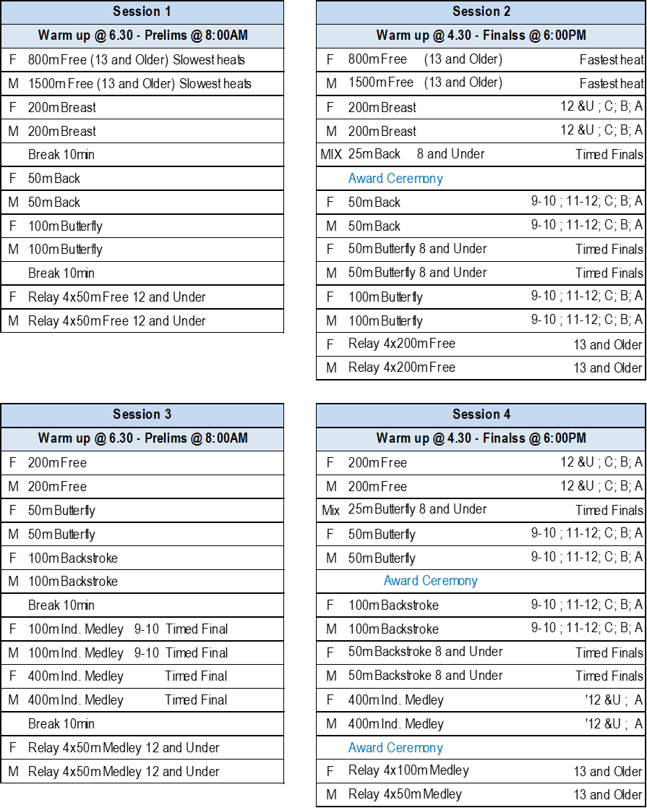



**ADDITIONAL INFORMATION**

Swimmers may enter either as an exhibition swimmer in an event or may request a time trial in an event of their choice. However, please note the availability of both exhibition swims and time trials **does not** change the qualifying/selection process for CARIFTA, Island Games or other meets.

The following are the definitions of time trials and exhibition swims to be used for the 2025 National Swimming Championships. Also, below are the conditions under which a time trial or exhibition swim may be requested for the 2025 National Swimming Championships.

**Exhibition swims:**

Exhibition swims are defined as non-scoring swims which take place during the actual regularly scheduled events or as a regularly scheduled event during the competition schedule.

Exhibition swims are offered only to swimmers from abroad (**non CIASA members**) and masters.

The followings are the conditions and procedures for exhibition swims for the 2025 National Swimming Championships.

1. Exhibition swims will be granted on a space-available basis. No new events or heats will be created for exhibition swimmers.
2. Male and Female swimmers may not compete in the same event and heat at the same time.
3. Swimmers must also swim in their correct age group as outlined in the meet information. If an individual is competing in a given age group for the meet that individual may not compete as an exhibition swimmer in an open or senior age group unless the event itself is not offered in the individual swimmer's age group.
4. An individual may only compete in and use a time for the event being contested by other swimmers in the event. Should the swimmer wish to have a split time recorded during the event the full event must be completed legally for the split time to count.
5. Exhibition swims will be non-scoring swims and no awards will be given for the swims.
6. Exhibition swims may be requested for open space as both or either a preliminary or final swim. Extra lanes will not be created in either preliminaries or finals.
7. Exhibition swims for prelims must be requested by 3pm the day prior to the day an event will be contested. Exhibition swims in finals must be requested within 30 minutes of the conclusion of prelims on the day of the event.
8. An exhibition swim will count in the number of individual swims allowed for the athlete in question .
9. Exhibition swims as preliminary swims will be seeded based on the swimmer's best time and seeding will be as outlined in the meet information for all swimmers. Seeding for finals will have the exhibition swimmer in an outside available lane, thus they will be seeded as if they have the slowest time in relation to the scoring swimmers but ranked with other exhibition swimmers if more than one individual is competing.
10. Each swimmer may compete in a maximum of two exhibition swims .
11. Requests for exhibition swims should be made to the Meet Referee, who will then consult the National Technical Director.

**Time Trials:**

Time Trial swims are defined as non-scoring swims which take place outside an actual regularly scheduled event or during the competition schedule. Time Trials may not occur during regularly scheduled events or competitions. Time Trials are conducted based on the request of the swimmer's coach. Time trials will follow the conclusion of a meet session. The scheduling of time Trials may not cause any meet session to go longer than **3 hours** (at the discretion of the Meet or Session Referee); including the normal event program and the time trials.

The following are the conditions and procedures for time trials during the 2025 National Swimming Championships:

1. Time Trials will be granted on a time available basis at the discretion of the Meet Referee.
2. Time Trial are not an additional event. A Time Trial can only be requested in an event for which the swimmer is already registered.
3. To benefit from a time trial, the swimmer must justify a previous time in the target event no greater than 1.5% off the target time.
4. Time trials apply to obtain qualifying times: CARIFTA, CCCAN, Island Games.
5. Reminder: a Time Trial will not be considered for National or CIASA records.
6. Swimmer's age groups have no bearing for Time Trials.
7. Time Trials will be non-scoring swims and no awards will be given for the swims. However, times will be considered official times.
8. Time Trials will not count in the number of individual swims allowed for the athlete.
9. Time Trials will be seeded based on the current meet format. Male and Female swimmers must be separated by at least one lane. Swimmers may request not to compete in a mixed male/ female event. In the event a single swimmer requests not to swim in a mixed event all individuals of the same gender will compete together.
10. Each swimmer may compete in a maximum of **TWO** Time Trials during the meet.
11. No Time Trials will be conducted following the Saturday and Sunday morning sessions of the 2025 National Swimming Championships.
12. Requests for time trial swims should be made 30mn before the beginning of session to the Meet Referee, or in the absence of the Meet Referee, the Session Referee, who will then consult the National Technical Director.
13. The entry fee is CI$10 per event

**Protests:**

Protests are possible:

a) if the rules and regulations for the conduct of the competition are not observed.

b) if other conditions endanger the competition and/or competitors, or

c) against decisions of the Referee; however, no protest shall be allowed against decisions of fact.

Protests must be submitted:

a) to the Head Referee

b) in writing on the appropriate form.

c) by the responsible team or coach.

All protests shall be considered by the Referee. If the Referee rejects the protest, the Referee must state the reasons for his or her decision.

All protests shall be considered by the Referee. If he rejects the protest, he must state the reasons for his decision.